### LAB NO:02

### Introduction to AVD(Android Virtual Device) and ADB(Android Data Bridge)

### TASK 1:

Task # 01: Create New AVD and Run your android project in your Virtual device.

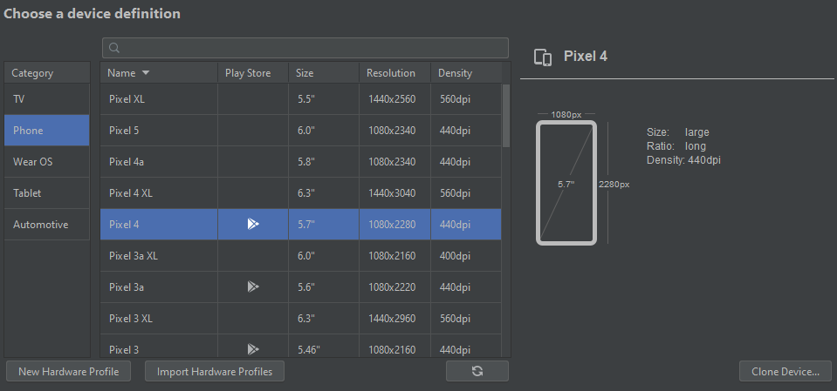

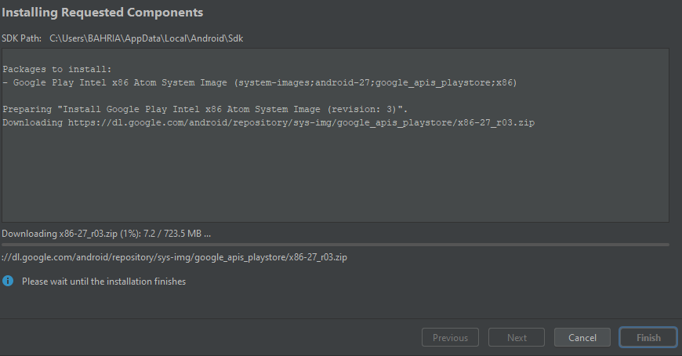

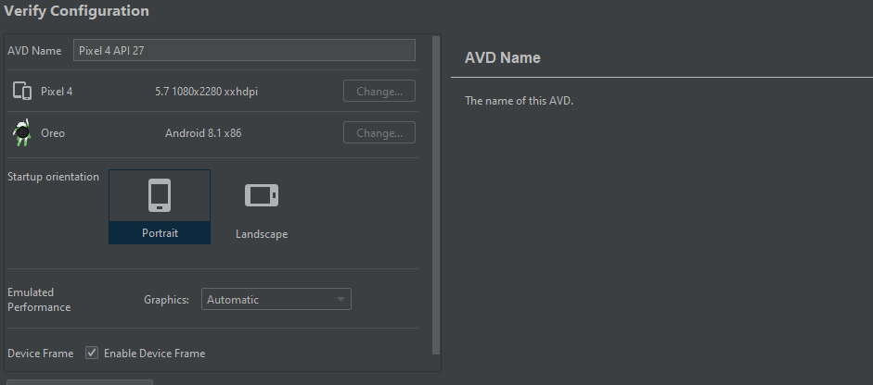

**OUTPUT:**



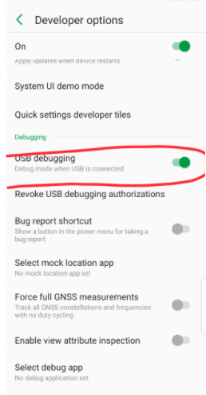**Task # 02:** Enable USB debugging in your Android Device.

### Solution:

### 